Page manager

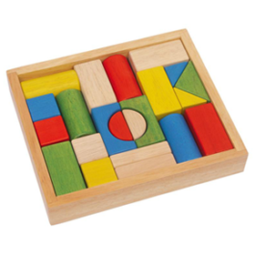

- Page manager is a tool for defining new, arbitrary paths on your Drupal site, and configuring how that page should look and work. It is possible not only to define new paths, but also to override some of the paths defined by other modules. One important part of the Page manager functionality is to collect and send contexts, contextual information that may affect the page.
- Panels is a tool for splitting the main content on a Drupal site into several regions and defining what content each region should contain.

Contextual objects
The settings for contextual objects (contexts) is, at least from an information structure perspective, the most important and most interesting part of Page manager. These settings allow you to gather information from other parts of the website, and make it available to modify the page's behavior and content.

Contextual objects are added in two different ways (see figure 13.6):
- By manual selection, for example a specific user or node. You may also use this to add the acting user as a contextual object.
- By relationships to existing contextual objects, such as the vocabulary for a loaded taxonomy term, or the author of a given node. This is the most common way of adding contextual objects.
A third way of adding contextual objects is the argument settings. These are loaded by dynamic parts of the path of the custom page.

Layout
One of the points of Panels is to allow you as administrator to split the main content into different regions. How this is done is determined by the panel's layout. Panels comes with a number of layouts, grouped by their number of columns.

Panel content
The last step of configuration is to add actual content to the regions in the panel. (See figure 13.9) This is done by clicking the gear for the relevant region and selecting add content. In the resulting dialogue you may select among available panes, pieces of content that can be placed in the panel. The panes are grouped into categories, to make them easier to browse. (See figure 13.10)
The panes available depends on the contextual objects available on the custom page. Some examples are:
- Block: All blocks on the website are available as panes.
- Page elements: Elements like tabs, the site name and the breadcrumbs can be used as panes.
- Node: If a node is available as context, different parts of the node and its related information may be used as individual panes, such as node title, the comment form or attached files.
- Entities: Most entities – such as users or taxonomy terms – can be embedded as panes, in a view mode you select.
- Entity tokens: Tokens built from entity data are automatically available as panes.
- Fields: All fields for the available contextual objects can be used as content panes.
- Existing nodes on the website can be added as separate panes, even without being available as contextual objects. This is done by the existing node option, in the lower-left corner of the dialogue.
- You can also add custom-written content as panes. This is done by the new custom content in the lower-left corner of the dialogue.
Each type of pane may have its own settings, or no settings at all. (See figure 13.11 for an example.) The pane settings are not described further in this book.

Editing panes
There are several ways of configuring and tweaking existing panes:
- The pane-specific settings can be changed by clicking the gear on the pane and selecting settings (or edit for some types of panes).
- One particularly useful setting is visibility settings, also accessibly through the gear menu. It allows you to use the same types of conditions used for access control and selection rules, to determine when the pane isvisible or hidden.
- Panes may be deleted by the remove option in the gear menu. They can also be temporarily disabled by the disable this pane option. They are re-enabled with the option enable this pane.
- You can set CSS IDs and CSS classes for each pane by the CSS properties option found in the gear menu.
- If the panel inherits its title from a pane, there is also an option in the gear menu for selecting this pane as the one used for setting the title.
- You may move panes between regions by clicking and dragging in the title list of each pane.
How can this be used?
A pane displaying the comment form can be displayed only if the active user is allowed to post comments.
A custom page displaying both the active user's recent content and the recent content by the author of a currently viewed node, can hide one of these lists if the active user is the node author.

Editing custom pages and variants
When all the steps for creating a custom page are over, you are brought to an overview of the custom page. (See figure 13.12) It contains a number of tabs on the left side and the main part of the page contains the settings for the selected tab. You may switch between the tabs to edit any of the settings described above, except the variant types (such as panel or HTTP response code), which cannot be changed.
At the overview page you will also find links to clone, export, delete and temporarily disable each variant The same settings are also available for the custom page as a whole. You will also find a link to add more variants to the custom page. Since Page manager will use the first variant with matching selection rules, there is also a reorder variants link.
How can this be used?
A variant without any selection rules on the node/%node custom page may be placed at the bottom of the variant list, to be used if no other variant fits.
A variant used to display articles may be cloned and then freely edited, to create a variant used for displaying basic pages.

Configuring HTTP response code pages
The procedure of adding and editing an HTTP response code custom page is short and easy when compared to creating panels. These types of variants, also have selection rules and contextual objects. The main configuration consists of a only variant name and the response code used on this path. (See figure 13.13)
There are three options for response codes: 404 page not found, 403 access denied and 301 redirect. The redirect option allows you to enter a path to which the user should be redirected. You may enter internal as well as external paths and you may use tokens provided by contextual objects.
How can this be used?
A website using nodes to build a catalogue of external web pages of interest for visitors, may use a redirect variant to send any visitor clicking on a node to the site it links to.
The same site may have another variant to check if the active user is allowed to edit the node, and if so redirect to the edit page instead.
When links are built, Drupal normally checks if the acting user is allowed to visit the target page. If the resulting page is a redirect, Drupal will only check if the redirect is accessible, not the page it ends with. Thus, you may end up displaying links leading to access denied pages if using redirects too vigorously.

Other modules using Page manager
Apart from Panels and Page manager, the only module providing variant types (known to the author) is Contextual Administration.
It is used to:
- build customized administration pages, for example to create new nodes with node references pre-populated,
- account creation pages where roles are set and hidden,
- placing an add term page in a section of the site where the terms actually are used.
Your site administrators will be happier if you learn to use it well.

Views content panes
In the last section of the last chapter in this book it is only fair to reward the devoted reader with one of the most powerful, flexible and fun tools for building information structure – Views content panes.
Views content panes is a module included in the Chaos tools suite project and it is an excellent bridge between Page manager/Panels and Views. The module provides a new Views display type, content pane. Displays of this type can be inserted as panes in a panel. It makes it possible to set parts of the view configuration, not least contextual filters, from the panel.
The two most important factors making this display type powerful are:
- You can control exactly how values for your contextual filters are fed to the view and what kind of data must be available in order to call the view. This means that you can completely ignore the clunkly (and frankly speaking quite hacky) options for creating default values for contextual filters. This is not only comfortable for you as Drupal developer, but also makes your views more secure and reliable.
- You can adjust quite a few settings for the view, for each panel you embed it in. In one panel you may use the acting user for building a contextual filter value and display ten results, and in another panel use a node author for the contextual filter and display three results. This decreases the need for separate displays and makes it easier to reuse your configuration. This in turn makes the site easier to understand, develop and maintain
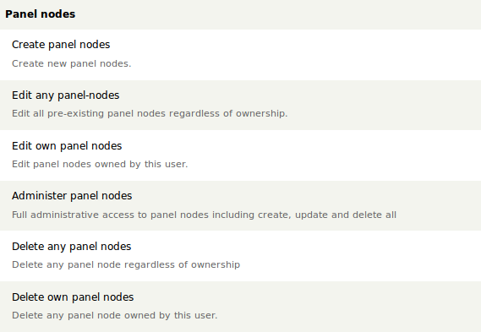
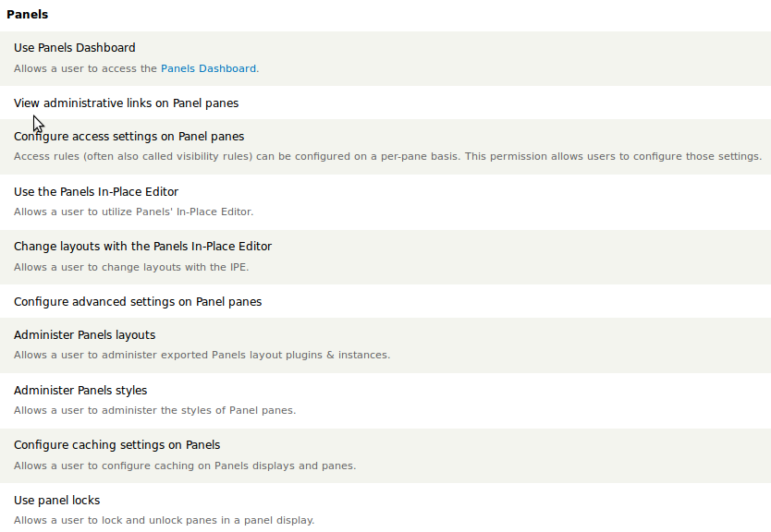
page manager

Info pagina:
Drupal.org | http://drupal.org/node/1582906
Tutorials:
Nodeone.se | http://nodeone.se/da/node/21
drupalize.me | http://drupalize.me/series/learning-page-manager
Drupal Camp Colorado 2011 | http://www.youtube.com/watch?v=gV0xs89mIOY
Panels, Panels Everywhere | http://sf2010.drupal.org/conference/sessions/panels-panels-everywhere.html
Learning Page Manager | http://drupal.org/node/1862908

Submodules:
Page manager search | http://drupal.org/project/page_manager_search
Page manager existing pages | http://drupal.org/project/pm_existing_pages
Panopoly pages | http://drupal.org/project/panopoly_pages
Nog veel meer | http://drupal.org/project/modules/Page manager?f[0]=drupal_core:103&f[1]=bs_project_sandbox:0

contextual administration

Module:
Drupal.org | http://drupal.org/project/context_admin
Tutorials:
Contextual administration algemeen | http://drupalize.me/videos/contextual-administration
Arbitrary Node Create | http://www.youtube.com/watch?v=Luc-bGGxa6c
VBO Administration Deployment | http://www.youtube.com/watch?v=M9KbemHvy4E
Custom Vocabulary Administration | http://www.youtube.com/watch?v=UNXCYeTZj7Y
Automatic Node Reference on Node Create | http://www.youtube.com/watch?v=BZxoUzIE5M4
Url Restructuring of Node View/Edit | http://www.youtube.com/watch?v=O4vvzSG7UAY
Creating an Administrative Section | http://www.youtube.com/watch?v=R5gpUfAXrAg

Panels

Module:
drupal.org | http://drupal.org/project/panels
Tutorials
Creating a custom Panels layout | http://www.youtube.com/watch?v=gmX2jnH9Kdg
Nodeone.se | http://nodeone.se/da/learn-drupal?field_nc_learning_version_tid=All&field_nc_learning_concepts_tid=&field_nc_learning_modules_tid=Panels

